LTWeb Operation Manual

Administrator

Version 1.2

February 23, 2016

Don Bellenger

[mobile1@uisdesign.com](mailto:mobile1@uisdesign.com)

240-426-1589

LTWeb – Version 1.2

**Overview of Operation**

1 Overview of LTWeb 4

2 Overview of LTWeb Operation – Client User 7

2.1 How Do I Get Started 7

2.2 Home Screen 7

2.3 Menu Options 8

3 User 9

4 Filing 11

5 RentalUnit – A Good Example of the LTWeb Controls 12

5.1 Grouping Records 12

5.2 Searching 12

5.3 Selecting 13

5.4 Operating on a Record and Going to Selected 13

5.5 Sorting 13

5.6 Initiating a Suit 14

5.7 Editing 15

6 History 16

7 Transaction 17

8 Task 20

8.1 Complaint Snapshot for a Rental Unit 21

8.2 Warrant Snapshot for a Rental Unit 22

8.3 Transactions Report 23

8.4 Make Spreadsheet for ALL IDs 24

8.5 Make Spreadsheet for MISSING IDs 32

9 LT Web Operation – Firm Administrator 33

10 User (Administrator Options) 34

11 Attorney 37

12 Court 38

13 Client 40

14 Property 41

15 Filing 43

16 Transaction 44

17 Tasks 46

18 Docket Report 47

19 Dismiss Report 48

20 Transactions without CaseNums Report 49

21 Assign Case Numbers 50

22 Delete Bad Case Numbers 54

23 Calculate Absolutes 57

24 Calculate Filing Stats 58

25 Make Complaints for the Report Engine 59

26 Make Excel Helper for EFiling Complaints 64

27 Make Warrants for the Report Engine 65

28 Make Excel Helper for EFiling Warrants 66

29 Options for IDs 67

30 Import Spreadsheet for IDs 67

31 Make Excel Helper Spreadsheet for Military Filing 71

32 Appendix – Setting up a New Client and User in LTWeb 74

33 Appendix - Setting up a New User with Chrome and TeamViewer 75

# Overview of LTWeb

What is it?

LTWeb is an Internet-based system that allows an LTWeb user to maintain an inventory of rental units, and periodically sue tenants for non-payment of rent.

LTWeb is operated by a legal firm, and is specifically maintained by that firm’s LTWeb Firm Administrator. The firm uses LTWeb to support several of its “Landlord/Tenant” Clients, each of whom are in turn managing one or more properties, each of which has several rental units, each of which has one or more tenants. Each Client will have an LTWeb user who enters changes to the Client’s inventory of rental units, including the list of tenants in each rental unit.

An LTWeb Firm Administrator can

* Create LTWeb user accounts
* Generate Forms for Court
  + Warrants
  + Complaints
* Generate Reports for Court
  + Docket Report
  + Dismissal Report
* Generate “helper” spreadsheets for EFiling
  + Complaints
  + Warrants
* Generate other reports to control the system
  + Transaction Report for a Filing
  + History for Tenants
  + Complaint Snapshot
  + Warrant Snapshot
* Track Case Numbers and Court Dates received from the courts, and publish the information to LTWeb Users, and to subsequent Docket, Dismissal and other reports.
* Perform LTWeb User operations on behalf the firm’s LTWeb client users.

An LTWeb User can

* Add, Update, or Delete rental units, thereby maintaining the user’s client’s list of rental units
* Request that the tenants in a unit be sued for non-payment of rent
* Generate various reports to help in these tasks.
* Transaction Report for a Filing
* History for Tenants
* Complaint Snapshot
* Warrant Snapshot

Benefits of LTWeb Operation

With LTWeb, procedures required to initiate and process suits are streamlined.

* Client Users maintain their inventory of rental units, tenants, and suit requests at their own workstations, with these results.
  + No need to assemble a list, and send it to the law firm.
  + Court Preparation
    - Up until 3 pm the day before a court date, a Client User can make changes in LTWeb – using the Transaction Menu Option to edit Transactions - reflecting **payments, partial payments, amended amounts, tenants vacating**, etc.
    - The Client User checks **Judgement** to indicate they are going forward with a Judgement, or clicks **Dismiss** to request that the case be dismissed.
    - The Client User should notify the Firm Administrator by phone or email when all changes are complete. The Administrator can then immediately print a new Docket and a new Dismissal Report, to interact with the Court.
  + No need for a Client to review a separate list coming back from the law firm, for errors.
  + Changes can be entered over time, and a transaction report generated at will to see the “suit list”.
  + Reduction in pressure.
  + Reduction in errors.
* Since LTWeb is based in a secure, off-site location
  + Reduced risk from catastrophic failure at law firm (fire, flood, break-in, staff issues).
  + Reduced risk, since many different workstations can access the database.
  + Automatic nightly backup of database.
  + Redundant power, redundant connectivity to the Internet.
  + Automatic upgrades to underlying hardware and software (operating system, database system, application development environment).

# Overview of LTWeb Operation – Client User

## How Do I Get Started

Log in with your User Name and Password as provided by the Firm Administrator.

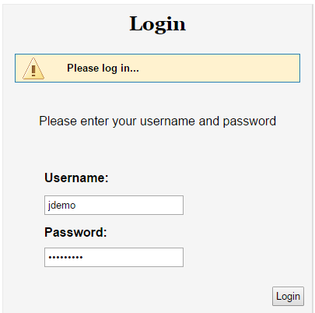

Figure

You will be presented with a simple Home Screen, with options to go to various sections of the system. These are described on the next page. Generally, you click on the options during your LTWeb Session, which ends when you click Logout.

**Note: There is a 30-minute inactivity timeout on your session. If LTWeb sits idle for 30-minutes, you will have to log in again.**

## Home Screen

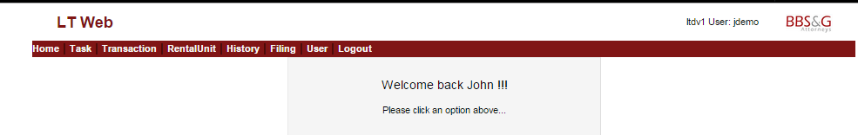

Figure

## Menu Options



Figure

**Home** – presents the screen above. This option is hardly ever selected.

**Task** – presents links for viewing various reports.

**Transaction** – shows the status of suit requests for the selected Filing. Here you enter changes since a suit was initiated (payments, etc.) **To be clear**, an action starts as a suit request when a user clicks “Sue” for a rental unit. An action may be dismissed, or simply deleted if it was a mistake in data entry. An Action may become a case when it is assigned a court date and case number.

**RentalUnit** – presents the interface for maintaining the inventory of units, and for initiating an Action (suit). To maintain a suit list, an LTWeb Client will spend most of the time in the **RentalUnit** option and the **Transaction** option.

**History** – shows the suit history of the currently-selected rental unit.

**Filing** – shows a list of Filings for your property, with the most current on at the top. A Filing is a collection of cases (suits) associated with a particular court date. Only one Filing can be open for new suits at a time. When you log in, you should click this option just to review “where you are”. A Filing is closed by the Firm Administrator when the Filing is used to generate Complaints to send to court. The next time you request to sue a tenant, a new Filing is automatically opened for you. You may have one Filing open for new suits, but select an older Filing in order to report on suits that are still being processed in that older Filing. If you then request a suit in the RentalUnit area, you will be brought back to the open Filing.

**User** – allows you to maintain your personal information, set your password, and set options such as “verbose” mode.

**Logout** – saves the selections you have made, and returns to the login prompt. Select this option when leaving your terminal even for a few minutes – for security reasons.

Next is a more-detailed review of these options, presented in order from right to left.

.

# User

When you click **User**, you will see the record your Administrator has set up for you. Occasionally, you might want to make changes. You can click on Edit, or Options.

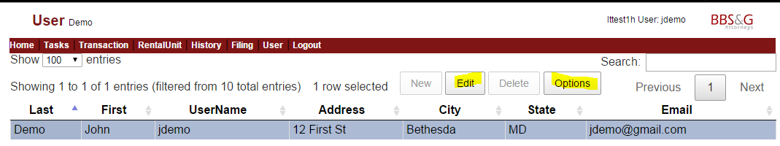

Figure

The Edit User screen allows you to update your information. Click Go to save your changes. Otherwise, click Cancel. You cannot change your Firm, Client, Property, or Role.

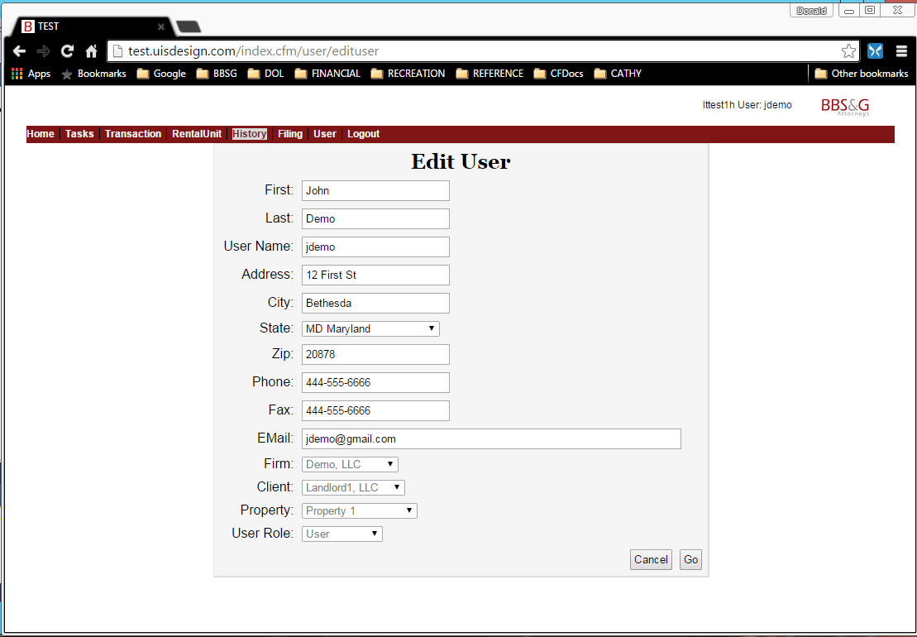

Figure

Clicking Options presents the following screen.

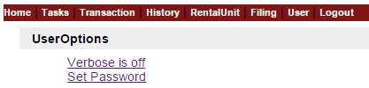

Figure

Clicking on “Verbose is off” will turn it on. You then will see “Verbose is on”. Clicking on that will turn it off. Verbose mode gives you an extra message when you change clients, properties, etc. Verbose mode is only useful when first learning to user LTWeb.

Set password allows you to change the password for the user, by entering the old password, and then a new password and a confirmation. Be sure to remember the new password, since there is no way to print it out.

# Filing

The Filing screen has the same general layout as many other LTWeb screens. After the screen title (“Filing”) is a “breadcrumb trail” showing how you got to this screen. Your login preselected the Client and Property for your LTWeb session. Your username appears at the top right.

Only the newest Filing is open (accepting new suit requests).

To select another filing, click on the **first** column in the row. For example, to select 4364, click on the 4456.

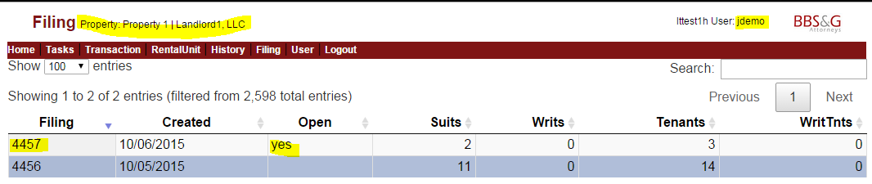Figure

You receive an alert saying you are changing to 4456.

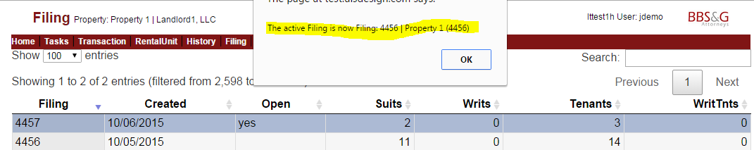

Figure

When you click OK on the alert, the 4456 row will be highlighted.

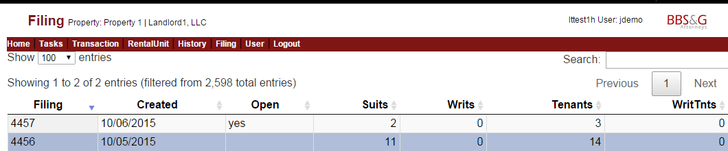

Figure

# RentalUnit – A Good Example of the LTWeb Controls

You will spend a large part of your LTWeb session in the RentalUnit Option. This contains a list of the rental units you have entered for your Property. The layout of this screen is similar to that of most of the other screens in LTWeb.

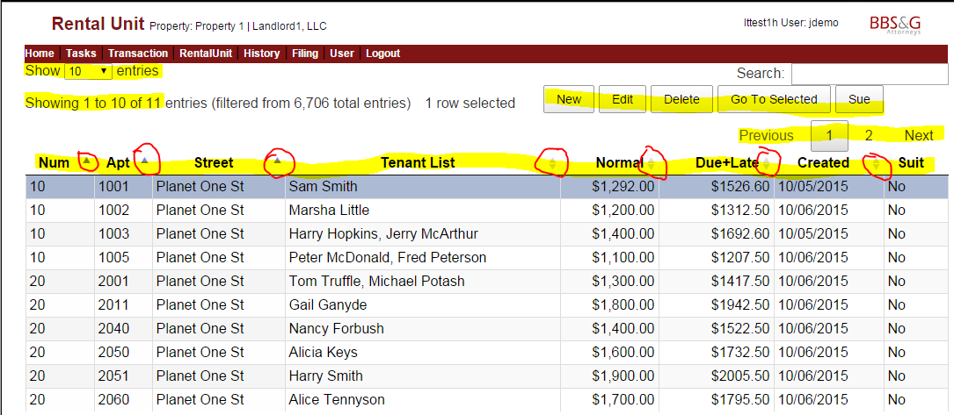

Figure

## Grouping Records

The left side of the heading (under **Home**) shows you are looking at the first group of 10 entries, out of 11 total for your property. Note that the terms “record”, “entry”, “rental unit”, and “unit” all mean the same thing.

You can change the number of rental units in a group, using the select box in the top left corner. You can navigate between groups of records with the Next… Prev controls on the right side of the header.

In general, having fewer records per group will mean faster response from the system, but having all the units in one group may be easier to use. With a good Internet connection and workstation, this might be your best option. You can select and change the group size whenever you want.

If you ever think something is missing, be sure to change to a large number of records per group, so you see everything.

## Searching

The right side has a powerful Search box – each letter you type will immediately search the **Num, Apt, Street, Tenant, Normal Rent, Due + Late, and Unit Create Date** (“Created”) columns in the list of units to narrow the list to match what you have typed. For example, typing “1003” will limit the list to records with “1003” in the Apt column.

If you are entering a new unit to sue, the Search provides a way to see if you have already sued other tenants at this address. If so, you can **Delete** the unit, and then **Add** it with the new tenants. This is necessary so that the calculation of judgement absolutes reflects the correct tenant list.

## Selecting

The blue highlighting in Figure 10 shows you have selected 10 Planet One St, apartment 1001.

You select a record on an LTWeb screen by clicking in the first column of that record - in this case, by clicking on the 10 in that record.

## Operating on a Record and Going to Selected

In the middle of the heading are options to

* **Add** a new rental unit (New)
* **Edit** the selected unit
* **Delete** the selected unit
* **Go to the Selected record**. This is the unit you highlighted. In this case, for example, if you move to the second group of records (records 11 to 11), and then click **Go To Selected**, you will return to the record you selected (“10 Planet One St, apartment 1001”). This can be a convenient alternative to scrolling a long list of records, or jumping between groups of records.
* **Sue** – Initiate a suit of the tenants in the selected unit (this is unique to the RentalUnit screen)

## Sorting

You can sort the records by clicking on the columns that have small indicators. The indicators are circled in Figure 10. In this example, there is an up-arrow to the right of Num, Street, and Apt. This means the current list is sorted from lowest to high on those fields. LTWeb has a special sort for these fields, which experience has shown is the most convenient. Clicking on any of these columns yields the same sort: Street, Street Number within Street, and Apt (apartment) within Street and Num.

Clicking a second time on one of the columns will reverse the order, so that the alphabetically highest street will show first (not necessarily a very useful option).

Looking at the right side of the next column in the example – Tenant List – we see a light-colored up and down arrow. This means the list is sortable on that column, but the list is not currently sorted on that column. So, clicking once on **Tenant List** will sort the records in order by the name of the first tenant. Clicking on **Tenant List** again will sort the records so that the “Z…” tenants appear first.

Other columns for sorting the list are Normal Rent, Due+Late amount, and Created. In particular, clicking on **Created** will present the records in the order you created the records. This can be useful when comparing the list of units to some other list you have of changes to be made.

(Similarly, you can click on the Creat column in the Transaction screen shown in to see the suits in the order they are created.)

## Initiating a Suit

The Sue Button – which is unique to the RentalUnit screen - allows initiating a Suit against the tenants in the selected RentalUnit. Clicking **Sue** will display a Suit Status message (Figure 12). Note that the Action number (TransID) always starts with the Filing number of the open filing..

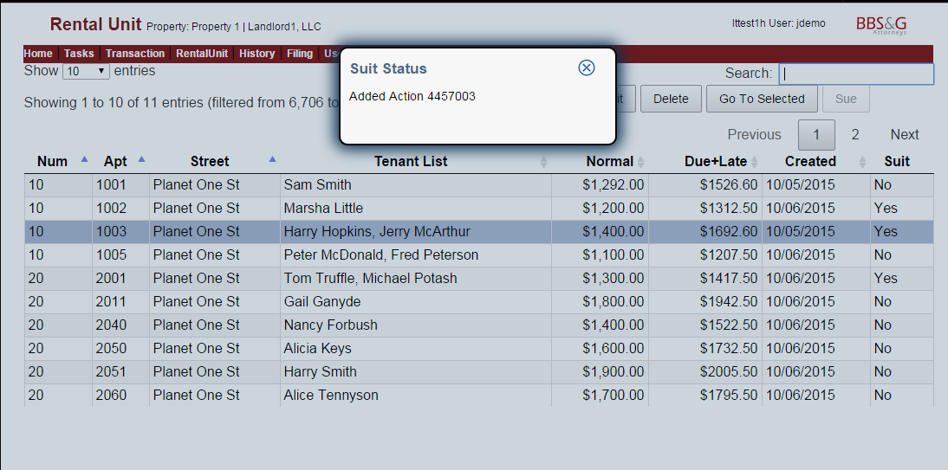

Figure

Note: if you need to make changes to any number (e.g. Rent Due) before suing, it is much easier to click **Edit**, make the changes, and click the **> Sue** checkbox in the Edit window, and click **Update** (see below).

## Editing

When you click **Edit**, a “bubble” pops up, with a header that confirms which unit you are editing.

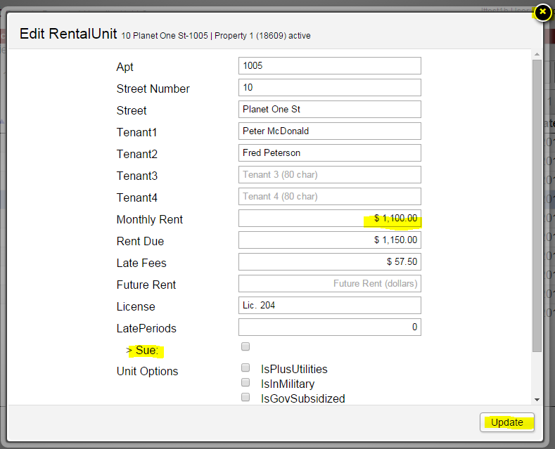

Figure

Enter your changes, and click **Update**.

If you do not click **Update**, no changes are made.

To close the bubble with making changes, click the **X** at the top right of the bubble.

To edit a money field, highlight the entire contents of the field, then type numbers and a decimal point. The $ and comma are maintained automatically. Note that if you Tab into the field, the entire contents are automatically highlighted for you.

When you enter Rent Due, LTWeb calculates Late Fees at 5%. **You can type over (change) this calculated number.**

To request a Suit be initiated against the tenants, click **> Sue** button before clicking **Update**.

# History

The History Option shows the suit history for the unit you select in the RentalUnit Option. For example, if you select the unit at 10 Planet One St – Apt 1003, then click **History**, you see

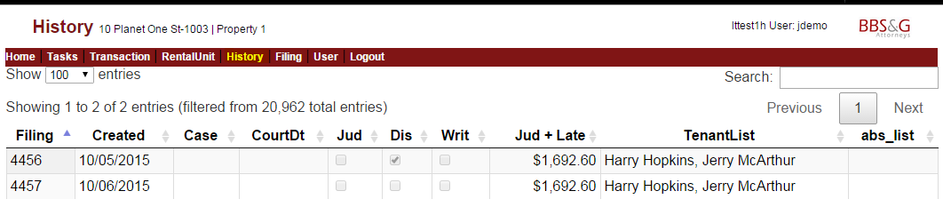

Figure

the suits related to the rental unit, with the filing, the date the suit was created, case number, court date, etc.

You check here to see what months have been sued, so you don’t sue twice for a particular month. Use this when you think there is more than one month owed.

# Transaction

The Transaction and Rental Unit screens are closely related. For example, if you use the Rental Unit screen to initiate a suit for a particular record in the current open Filing …

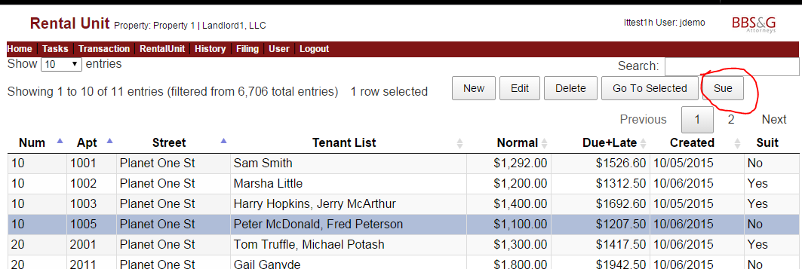

Figure

… and then click **Transaction**, and **Go To Selected**, you see the new suit. It is under the open Filing: 4457.

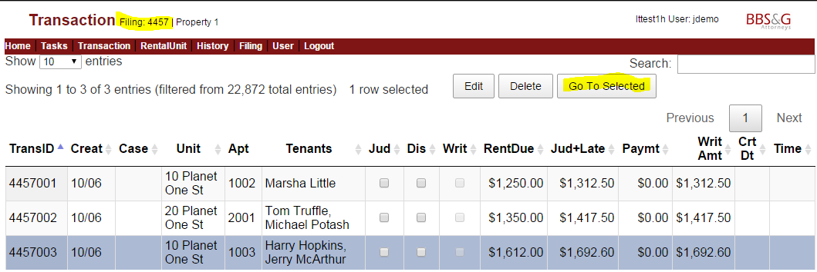

Figure

Another way to see the new suit in the Transaction Option is to click on the **Creat** column heading twice, invoking a sort, so that the most-recently-created suit is at the top of the list. (Note, **Creat** is an abbreviation for Created. LTWeb uses this abbreviation so that everything fits on the monitor at 1280 x 720 resolution).

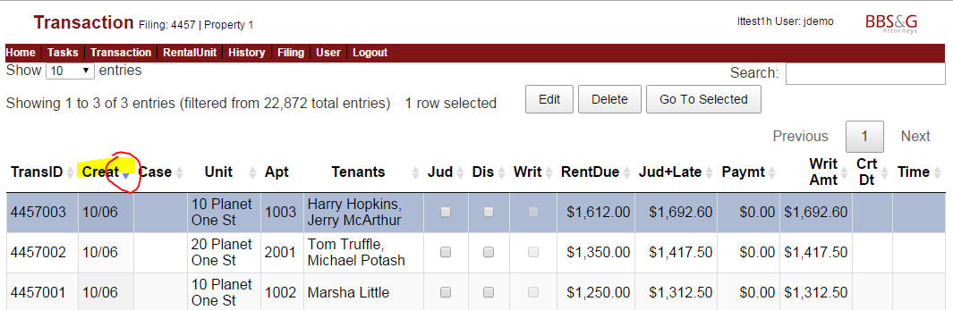

Figure – Transaction Screen

**Court Preparation** - Up until 3 pm the day before a court date, a Client User can make changes in LTWeb – using the Transaction Menu Option to edit Transactions - reflecting **payments, partial payments, amended amounts, tenants vacating**, etc.

The Client User checks **Judgement** to indicate they are going forward with a Judgement, or clicks **Dismiss** to request that the case be dismissed.

The Client User should notify the Firm Administrator by phone or email when all changes are complete. The Administrator can then immediately print a new Docket and a new Dismissal Report, to interact with the Court.

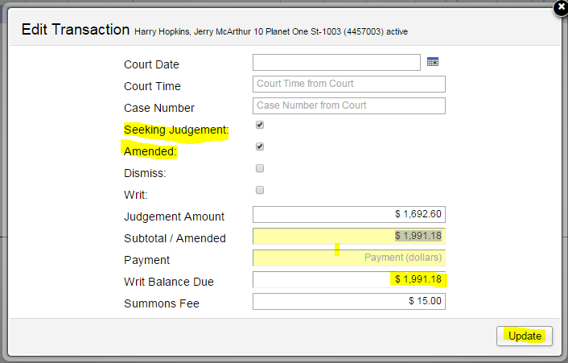

Figure

Typically, an LTWeb User clicks **Seeking Judgement** when it is decided to file the Complaint with the Court.

It the tenant has made a payment, or other arrangements, before the Complaint is to be sent to Court, the LTWeb User clicks **Amended**, and enters the new amount for the suit into the **Subtotal/Amended** field. At this point, the **Payment** field should be set to 0. The **Writ Balance** Due field is automatically calculated.

Whenever the **Amended** box is checked, the **Judgement/Amount** will show as amended in various reports, including the Docket.

As in all LTWeb screens, click **Update** to make the update “stick”, otherwise click the **X** at the top right of the bubble.

Alternatively, the LTWeb User might click **Dismiss**. The complaint will be deleted from Docket, and not sent to Court.

The Firm Administrator maintains the **Court Date**, **Court Time**, and **Case Number** fields.

# Task

When you use the Tasks Option, you will notice interactions between Task, Transaction, and Filing.

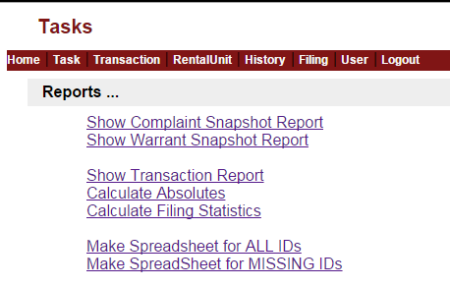

Figure

The first two reports are for a single Transaction you have selected under the Transaction Option. On the other hand, the **Show Transactions Report** is for all the Transactions in the Filing you have selected. The reports are shown on the next page.

**Calculate Absolutes** scans all the units in the current Filing, to ensure the calculations are up to date. This calculation is also automatically performed when the Firm Administrator **Makes Warrants** to send to the court.

Similarly, the **Calculate Filing Statistics** option calculates the filing statistics for the current filing. This is also automatically performed when the Transaction Report is run.

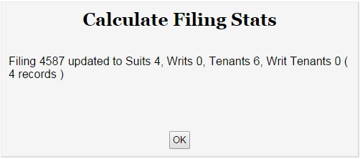

The options concerning Spreadsheets for IDs relate only to the current filing.

## Complaint Snapshot for a Rental Unit

This is the Complaint Snapshot for the Transaction with Transaction ID 4457003. This Transaction was selected under the Transaction Option, before the report was produced. It is a good review of what will be submitted to court on a Complaint form.

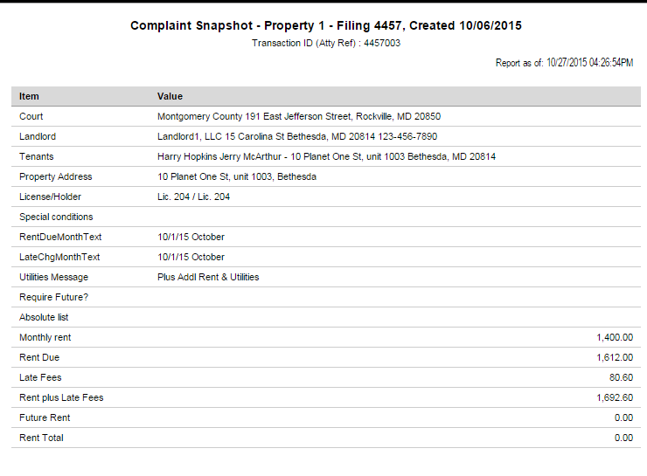

Figure

## Warrant Snapshot for a Rental Unit

This example shows the Warrant Snapshot for the Transaction with Transaction ID 4457003. This Transaction was selected under the Transaction Option, before the report was produced. It is a good review of what will be submitted to court on a Warrant form (Writ of Restitution).

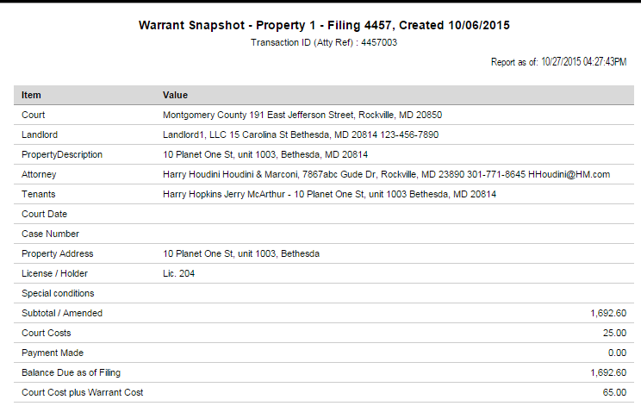

Figure

## Transactions Report

This report is very convenient for reviewing your data entry for a particular **Filing**, and to see history of units in the Filing, at any time before the Filing is used to file complaints or warrants with the court.

In the example, the rows are sorted by Case Number, because the user sorted the Transactions under the Transactions Option by Case Number before producing this report. Note that unit and tenant counts are given at the top of the report. If an amount has been changed since the original Transaction was created, and marked “Amended”, the new amount is flagged with an asterisk.

When the report is sorted by CaseNum, if there is a break in the sequence of case numbers, “*SQ” is appended to the case number. If there is a missing Case Number, it shows as BLANK.

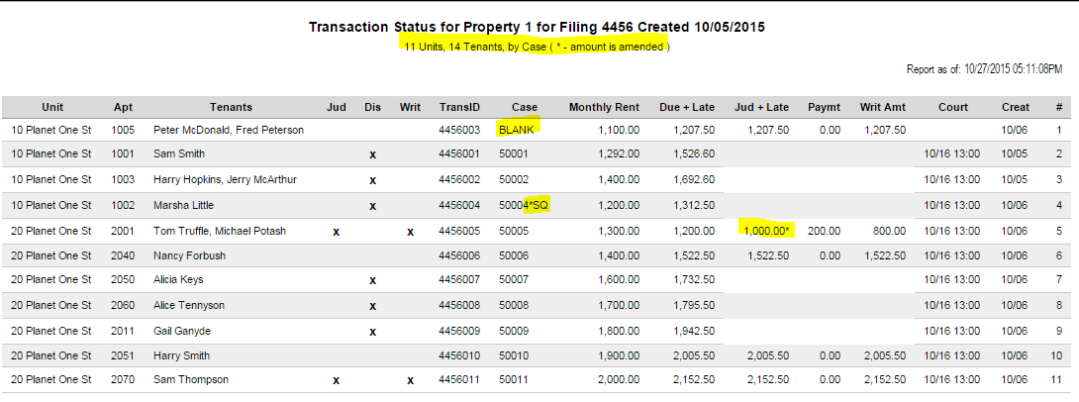

Figure

## Make Spreadsheet for ALL IDs

The court requires that you provide an ID or birthday for everyone you sue in a particular Filing. LTWeb helps by allowing you to enter this number only once, for each Tenant. You never have to enter the ID again, for this Filing, or for any other Filing where you sue the same Tenant in the same Unit.

Here is the procedure in one sentence. You download a spreadsheet, load it into Excel, update the missing IDs OR Birthdays, save the spreadsheet, and email it back to your System Administrator.

Here is an example with all the details. For our example, here are the transactions in a simple filing, where you are suing 11 people in 8 rental units.

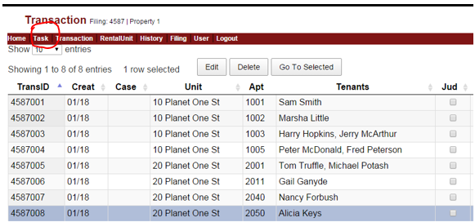

* To start, be sure you are in the correct Property and Filing for the IDs you are updating
* Then, go to Tasks, and click **Make Spreadsheet for ALL IDs**. Click Go. This will download an Excel spreadsheet, based on the filing, to the Download area of your browser. See the following screenshots for a detailed example.
* Click Go to download the spreadsheet. Notice that the file appears in the download area of Chrome (or Internet Explorer, depending on which browser you are using).

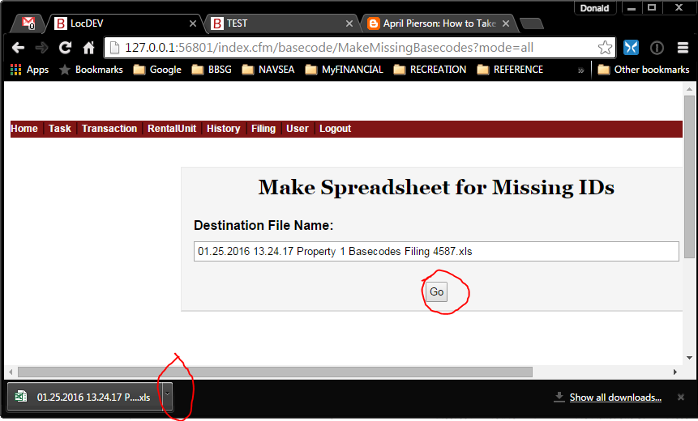

* In Chrome, click the small up-arrow to the right of the file name, and select **Open**. This will bring up the file in Excel. If this doesn’t work, close any Excel spreadsheets you have open, and close Excel. Then try to **Open** the downloaded file again.
* IF you see this “Protected View” header when you open the spreadsheet, click **Enable Editing.** The “Protected View” header will disappear.



The following screenshot shows the spreadsheet successfully opened in Excel, with Editing Enabled..

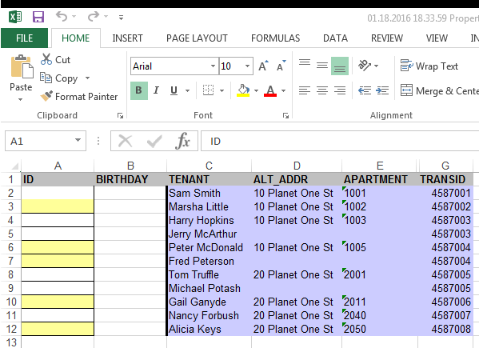

In our example, here are 12 rows – one header row, and one row for each tenant. The shading helps tie the tenants to the units. You may have hundreds of rows.

* At this point, when starting with the spreadsheet, it is very important to right-click on the Excel column heading of the first column. This is “A”. (See screenshot below).
* Select “Format Cells”, and “Text”. This will allow you to enter a leading zero in an ID. This is a very common case (e.g. 014992121).

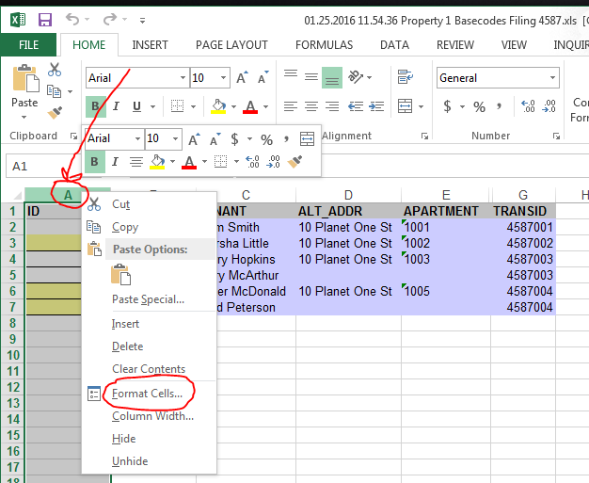

* On the Resulting pop-up, under the Number Tab, click on **Text**, and **OK**.
* To complete the Format Cells procedure, click on an Excel cell that is NOT in the first column.

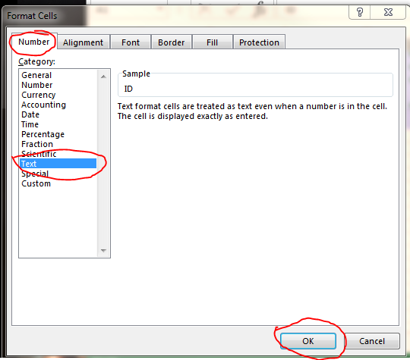

* Once you have completed the Format Cells procedure, type in EITHER the ID in the first column, or the birthday in the second column, for each tenant. Here is the spreadsheet partially filled in.

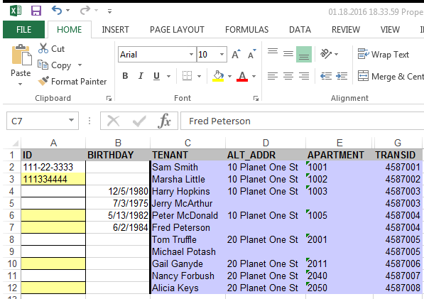

You can enter the ID’s with or without “-“. The dates are automatically formatted when you enter them.

* Complete the spreadsheet
* Save it (“File, Save”)
* Close Excel
* Email the completed spreadsheet as an attachment back to your System Administrator.

Here is what emailing a spreadsheet to Cathy might look like, if you are using Microsoft Outlook.

* Start with Outlook open, and click **New Email**

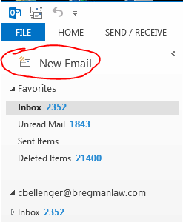

* **Fill in the To, CC, Subject, and click Attach File**
* 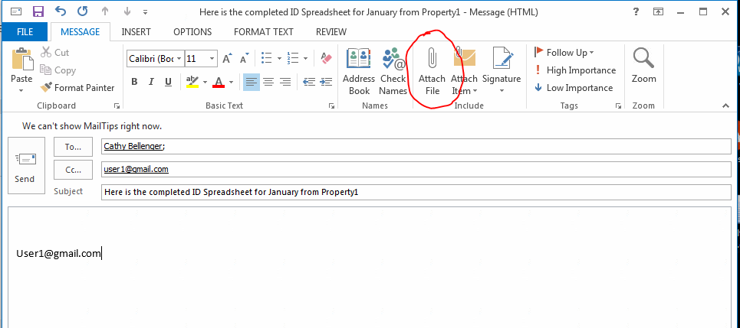
* Find the correct file! This might be the hardest part. Normally, the file will be in your download folder, and be the most-recently-changed file. Clicking on the Date Modified column once will bring the most-recently-changed file to the top of the listing. Click on the name of the file once, and click the **Insert** button.

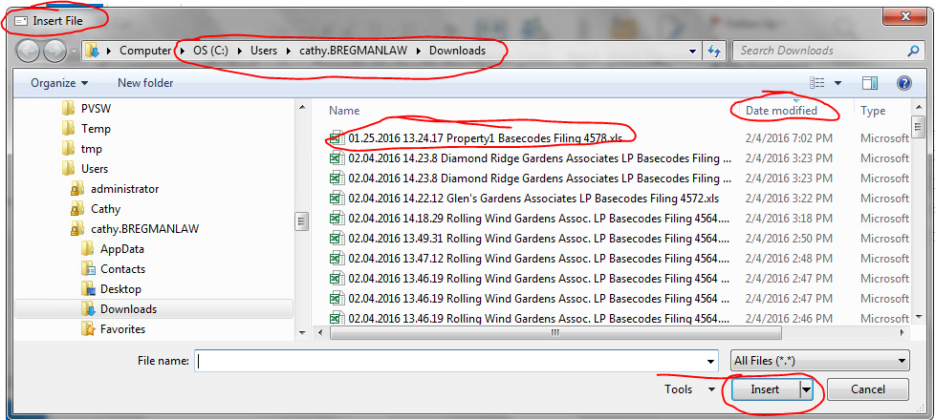

* **Once the file is attached, click Send.**

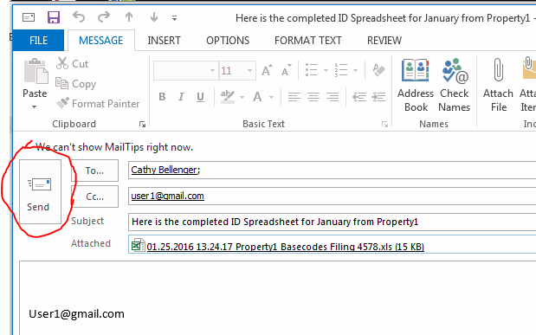

Continuing our detailed example, notice that the spreadsheet above was not completed. So, if you email this spreadsheet to your System Administrator, she will contact you soon to request that you

* Repeat the procedure above to **download a new spreadsheet**, reflecting the work you have done
* Finish entering IDs for remaining tenants.
* Email back your revised spreadsheet.

Here is what you would see in our example case, if you downloaded the **new** spreadsheet, and opened it in Excel.

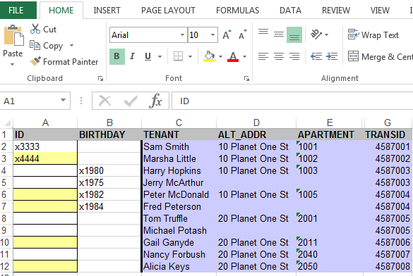

**Notice that any entries you have made have been saved by the System Administrator! You do not have to enter them again, for this Filing, or for any other Filing with this same Tenant in the same Rental Unit**.

* Finish entering IDs or Birthdays for the Tenants in lines 8-12
* Save the spreadsheet
* Email it to your System Administrator.

## Make Spreadsheet for MISSING IDs

This is similar to **Make Spreadsheet for ALL IDs**, except the resulting spreadsheet contains ONLY those records that need data. That is, Tenants that already have an ID or Birthday are not in the spreadsheet. This may make it simpler to identify those records that need to be updated.

Here is the sample output for our test case.

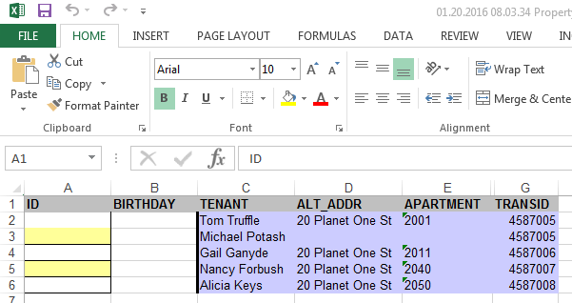

# LT Web Operation – Firm Administrator

When LTWeb determines based on your logon that you are a Firm Administrator, your home screen has more options. These include the options that are available for a Client User, as described above; you may make any entry that a Client user can make, on their behalf.

This section only describes the additional Options – not available for a Client User - you can use. The descriptions are in order from right to left on the banner in Figure 12

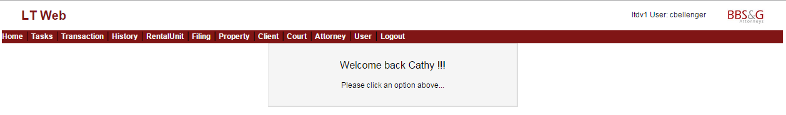

Figure

# User (Administrator Options)

The User Option is where you register new LTWeb Users for new and existing Clients of your Firm. The initial screen operates in a similar way to the other LTWeb screens. In addition, there is an Options button, which we will cover below.

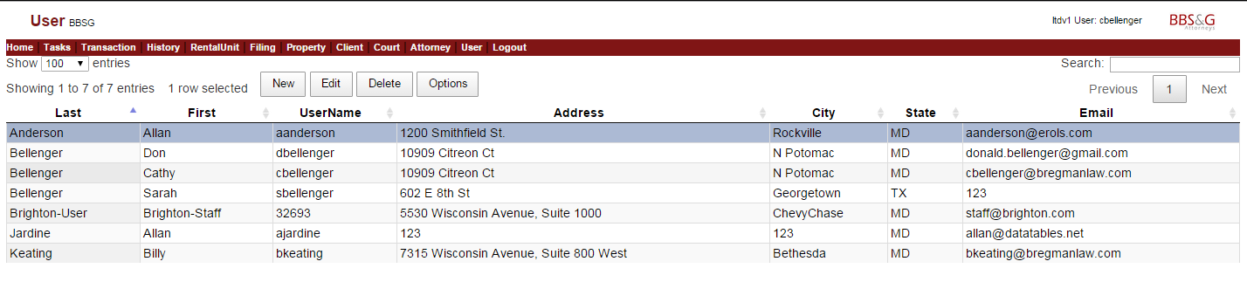

Figure

Most edits are done by selecting a user, and clicking Edit. Adding a new user is very similar, except you start by clicking New. Clicking the Delete button allows you delete the selected user.

The Edit User screen is slightly different from Edit screens for other tables.

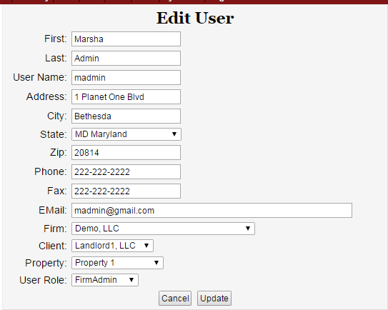

Figure

One significant difference is the Cancel and Update at the bottom. Click Update to save the changes you make on the form. Clicking Cancel will leave the form without saving changes.

For a Firm Administrator (FirmAdmin) for a particular Firm (e.g. BBSG), the operation of the selects for Firm, Client, Property, and User Roles is as follows.

* Firm: Allows selection of one Firm: BBSG
* Client: Allows selection of one of the landlords (clients) who the Firm is supporting with LTWeb
* Property: Allows selection of one of the properties of the selected Client
* User Role: Can be one of the following
* User: This is a person who can maintain records for the selected property
* ClientAdmin: This is a person who can maintain records for any property belonging to the selected Client (landlord).

Once you have selected a user in the initial window, you may click Options. This presents the following screen.

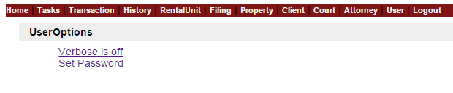

Figure

Clicking on “Verbose is off” will turn it on. You then will see “Verbose is on”. Clicking on that will turn it off. Verbose mode gives you an extra message when you change clients, properties, etc. Verbose mode is only useful when first learning to user LTWeb.

Set password allows you to change the password for the user, by entering the old password, and then a new password and a confirmation. Be sure to remember the new password, since there is no way to print it out.

When a new user is created, the password is initially the same as the username. This should be changed immediately, for better security.

Passwords must be at least 8 characters long, contain an upper case letter, a lower case letter, a number, and one of these special characters: **~ ! @ $ % ^ - _ = + | : ?** .

# Attorney

The Attorney option allows maintenance of records for the Attorneys that appear in L&T cases. Various fields here appear on Complaint and Warrant of Restitution forms LTWeb generates for Courts.

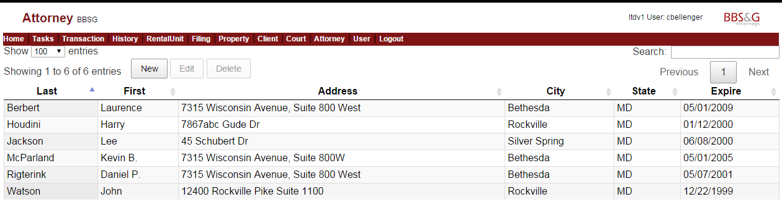

Figure

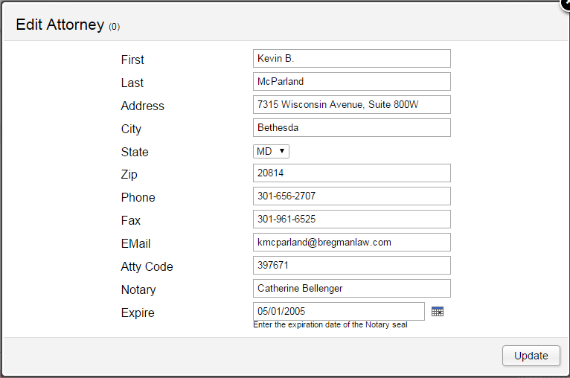

Figure

# Court

Similarly, the Court records contain fields that appear in Court documents submitted by LTWeb.

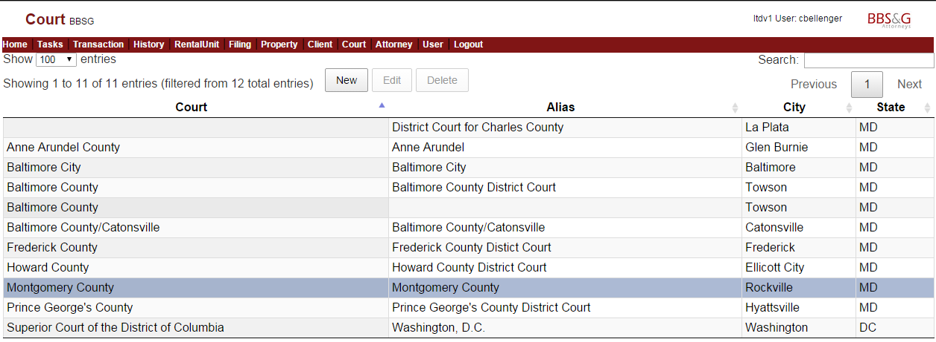

Figure

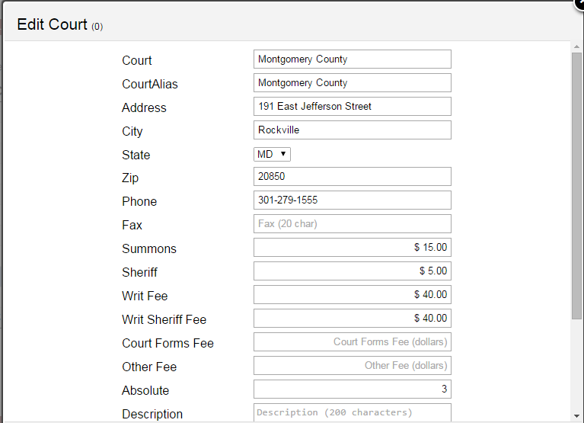

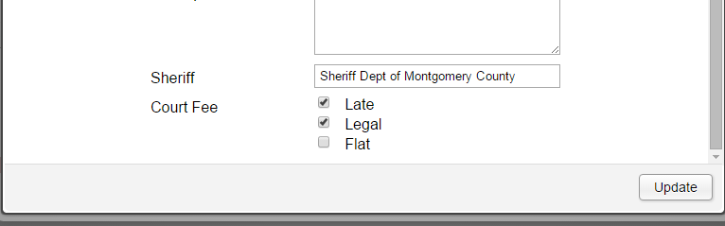

Figure

# Client

A client may have more than one property. All Filings in LTWeb are by Property. Also, LTWeb Users are assigned to particular Properties. But the Client record contains important underlying fields.

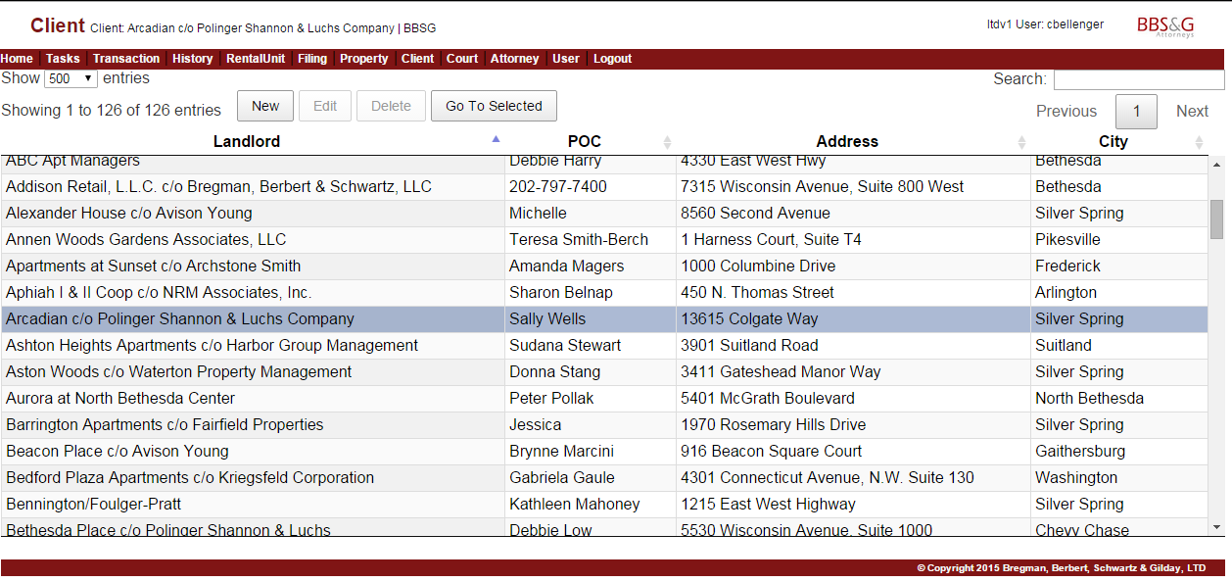

Figure

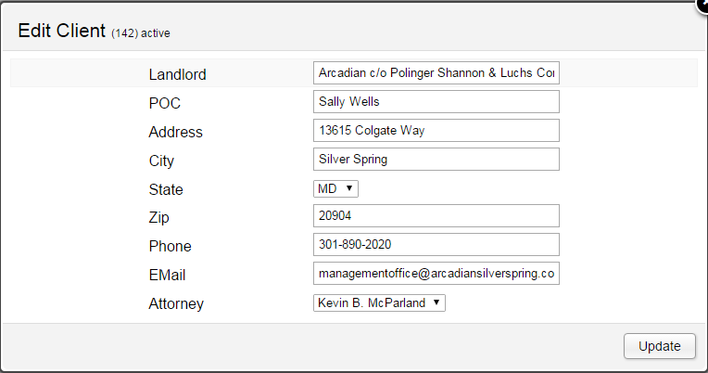

Figure

# Property

A client may have more than one property. All Filings in LTWeb are by Property. Also, LTWeb Users are assigned to particular Properties. But the Client record contains important underlying fields. Once you select a Client, you select the related Property. Often, there is only one Property for a Client.

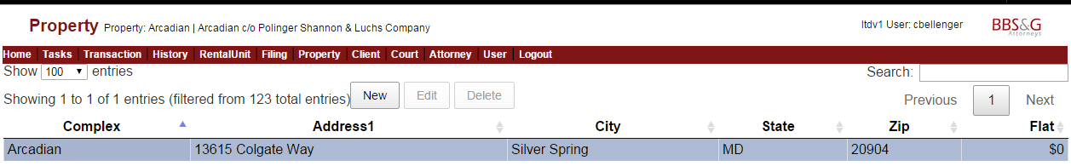

Figure

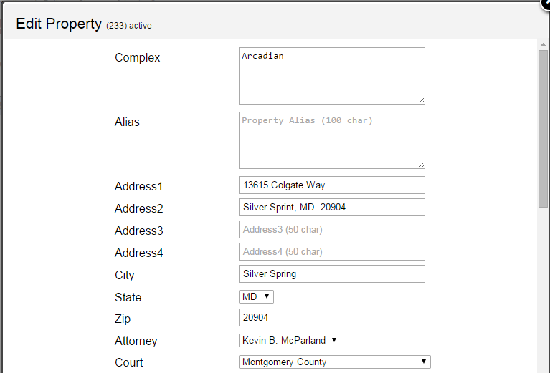

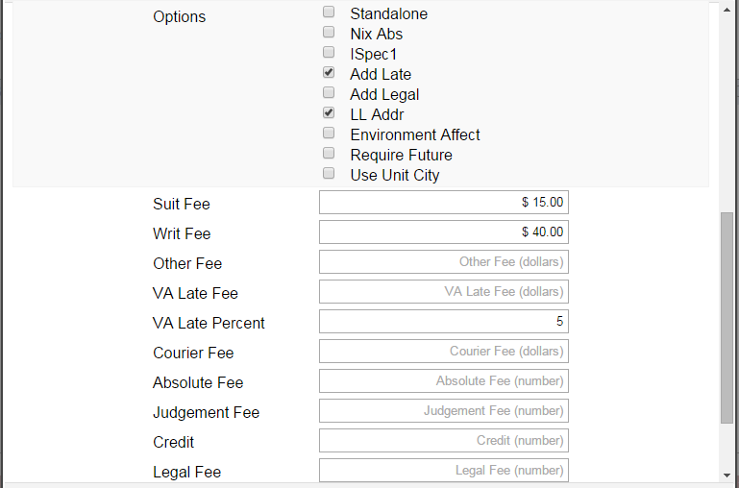

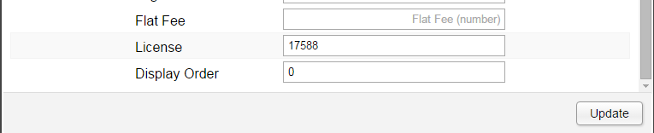

Figure

# Filing

The Filing screen for an Administrator is the same as for a Client User, with the exception that a Firm Administrator can close a filing. After a closing, the next suit created for a Property will go into a new Filing. The Firm Administrator is responsible for coordinating the LTWeb Filings with her interactions with the Court.

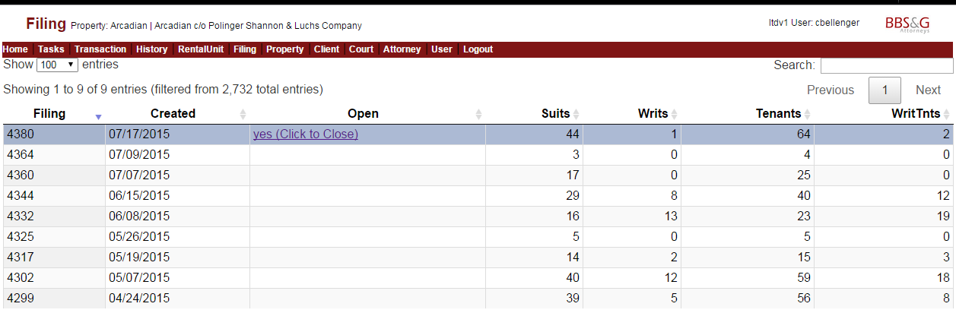

Figure

# Transaction

Since the Firm Administrator might be assigning the same Court Date for a number of Actions, we have a shortcut method for this task. For example, you might enter a court date for one Transaction, and click Update to post the change.

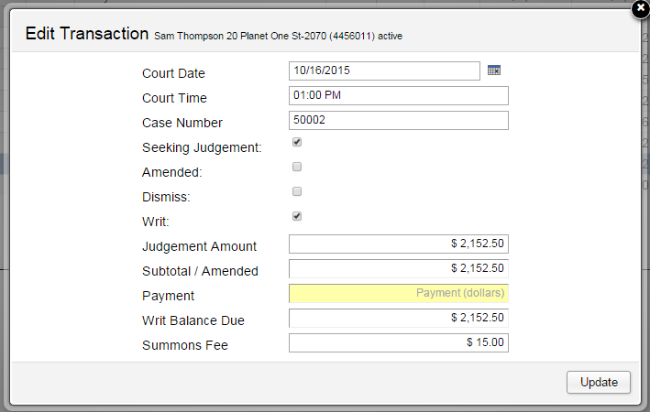

Figure

When you edit the next Record, the Court Date and Time are remembered from your previous entry. You will enter a unique case number for this transaction. These values are not posted to this transaction until you click **Update**.

The Court Date presents a calendar for ease of entry. Time presents a dropdown of entries like “1:15PM”. You can just type “115” to make that selection.

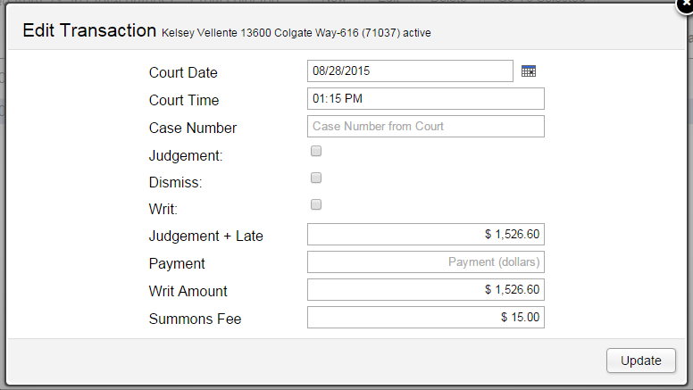

Figure

# Tasks

A Firm administrator has a number of capabilities not available to a Client User. Those available to the Client have been discussed in the user section of this document, in section 4 - Tasks.

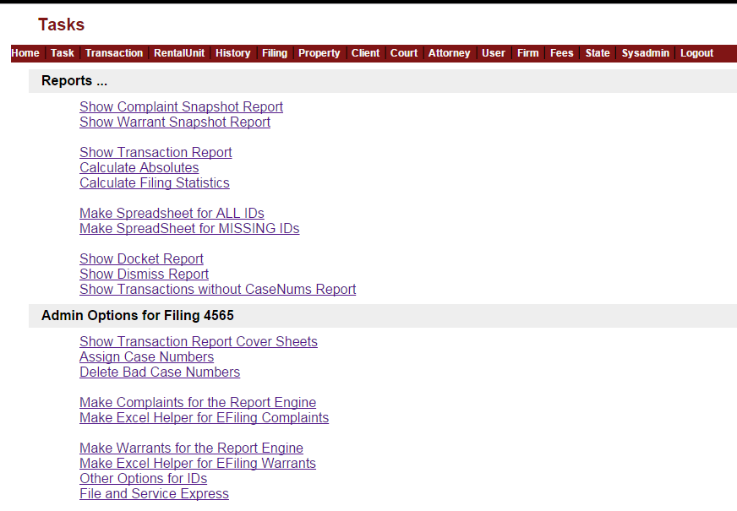

Figure

# Docket Report

The Docket Report displays the Actions from all clients, for the particular court date and time.

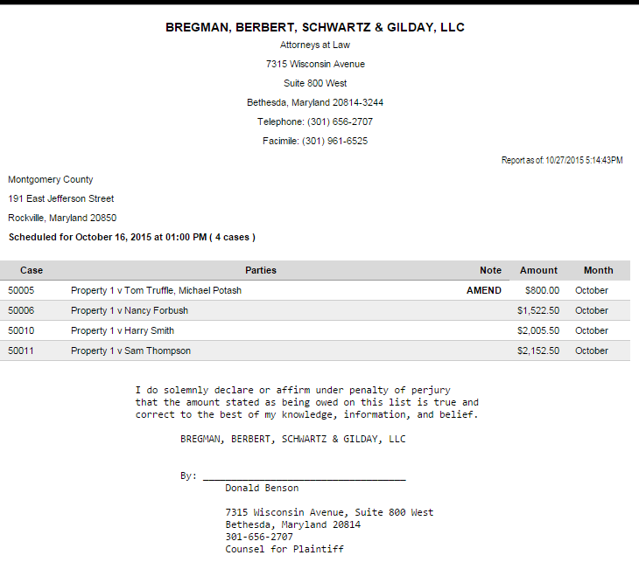

Figure

# Dismiss Report

The Dismiss Report shows the cases that are to be dismissed, for a given Court and time.

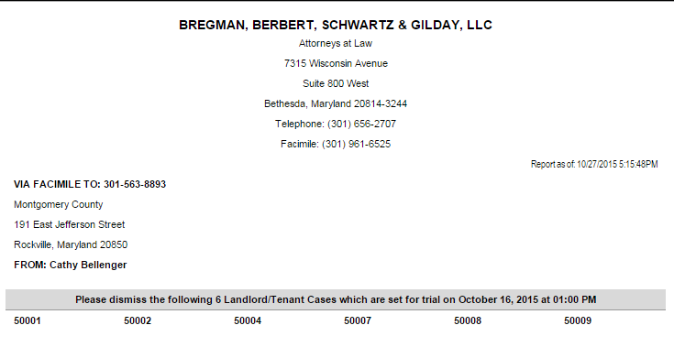

Figure

# Transactions without CaseNums Report

This report provides an easy way to find any Transactions that do not have Case Numbers assigned. This is important just before a Docket and/or a Dismiss Report are sent to Court.

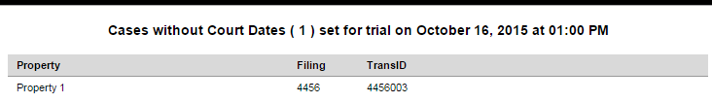

Figure

# Assign Case Numbers

When a Court returns a stack of complaints, with case numbers assigned, it is frequently possible to take advantage of the fact that the case numbers are in order by the TransID in LTWeb. This allows assigning Case Numbers, Court Date, and Court Time in a batch.

LTWeb supports this with two screens side by side on your monitor. If you have two monitors, this is even easier. After you are in the Transactions Option for the correct Property and Filing, sort the Transactions by TransID, by clicking that column heading. Then click **Tasks**, and **Assign Case Numbers**. This opens a new tab or window.

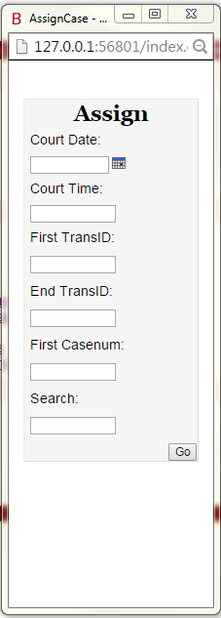

Figure

Arrange this tab to be next to your LTWeb window, so that the right edge of the LTWeb window overlaps the Assign CaseNums window.

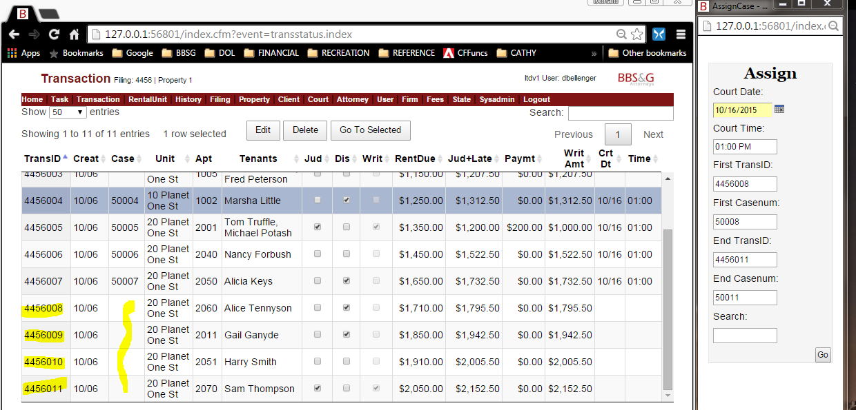

Figure

In this example, we can see that transactions 4456008 to 4456011 need case numbers. This matches what we have from the court. Make the entry in the “Assign” window, using the case number stamped on the complaint by the court, and click **Go**.

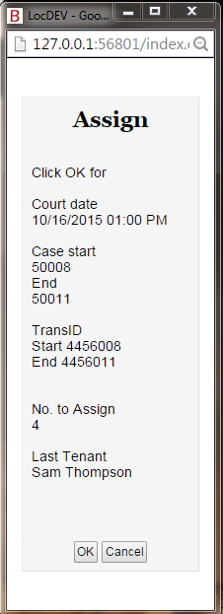

Figure

Review the information, and click OK or Cancel. If you click OK, the assignments are made, and you are ready to do the next assignment. The Assign window retains your previous entries, so you can change only what is necessary for assigning the next batch of case numbers. When you are finished assigning case numbers, simply close the Assign window by clicking the X at the top right. You may have to refresh the Transaction screen (press crtl-F5 in Chrome) to see the newly-assigned case numbers.

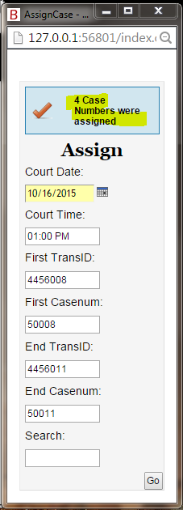

Figure

# Delete Bad Case Numbers

This Task allows you to clear a set of Case Numbers that were assigned in error. With the correct Filing selected, select the Court and Date, and a range of TransIDs for which you want to delete the CaseNums and Court Date. Also, enter the CaseNum that is on the first transaction, and the CaseNum that is on the last transaction. These CaseNums are just used for verification that you have selected the correct range of transaction for deleting the CaseNums.

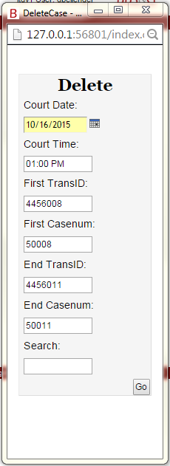

Figure

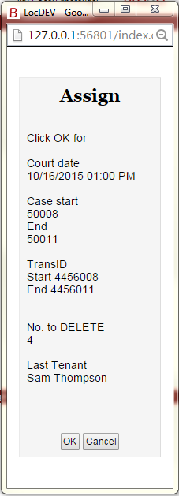

Figure

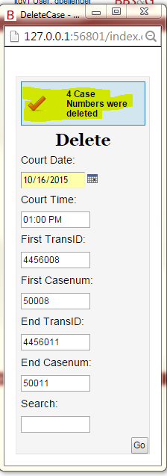

Figure

You can continue by entering the next batch of CaseNums to be deleted. When finished deleting CaseNums, close the window by clicking the X at the top right.

# Calculate Absolutes

Calculate Absolutes is a utility function to check that each rental unit in the current property has been scanned, counting the number of suits in the last year. Over three suits implies that the court is asked for a Judgement Absolute.

This function is automatically run whenever you run **Show Warrant Snapshot Report**, or **Make Warrants for the Report Engine**, in order that the warrants reflect absolutes that are right up to date.

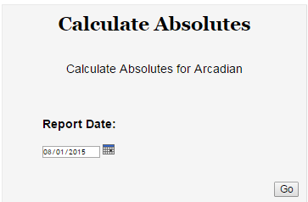

Figure

Just confirm the Report Date, which is the first day of the current month. LTWeb will scan the rental units for the previous 12 months, and return the count of how many new absolutes were detected. Click OK.

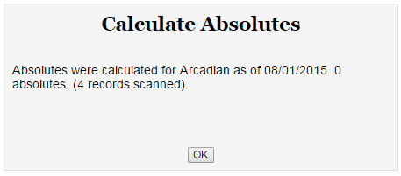

Figure

# Calculate Filing Stats

This calculates the current statistics for the current Filing. This can be useful in cross-checking against information from the court, and from clients. It is automatically run whenever a Transaction in the Filing is updated.

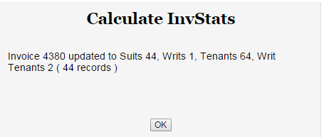

Figure

# Make Complaints for the Report Engine

To print Complaints on preprinted forms, the first step is to make the table of complaint records, based on the current Filing. Click **Make Complaints for the Report Engine**.

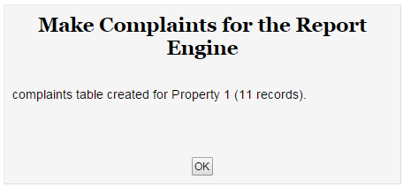

Figure

Then from your desktop, start the Report Engine, by clicking on the appropriate icon.



Figure

Click **External Data**, **Linked Table Manager**.

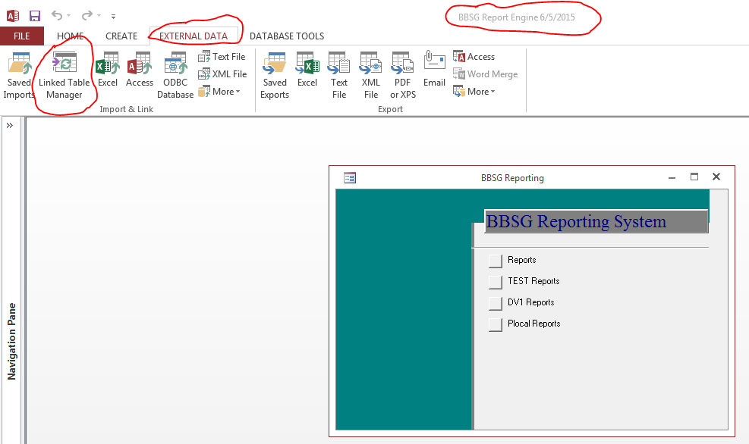

Figure

Click Complaints, or Warrants, or both. Then click **OK**, and **Close** on the confirmation messages.

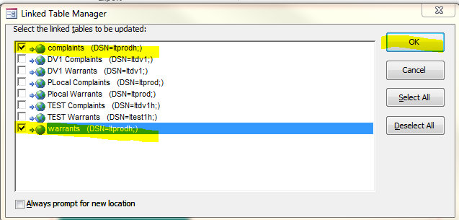

Figure

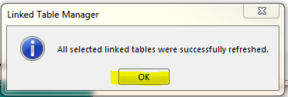

Figure

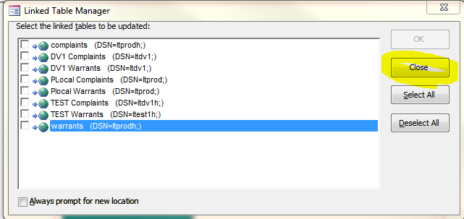

Figure

Click **Reports**, and then **Complaints** or **Warrants**, as appropriate.

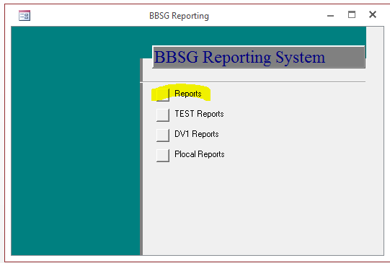

Figure

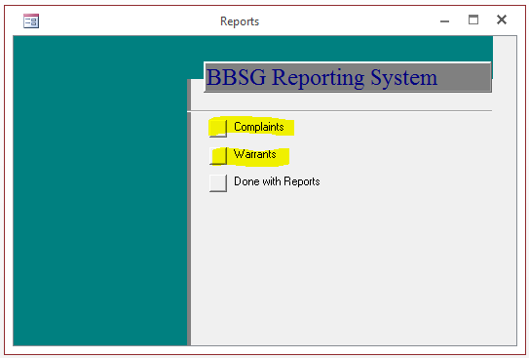

Figure

You then have a navigation pane through the complaints, or warrants

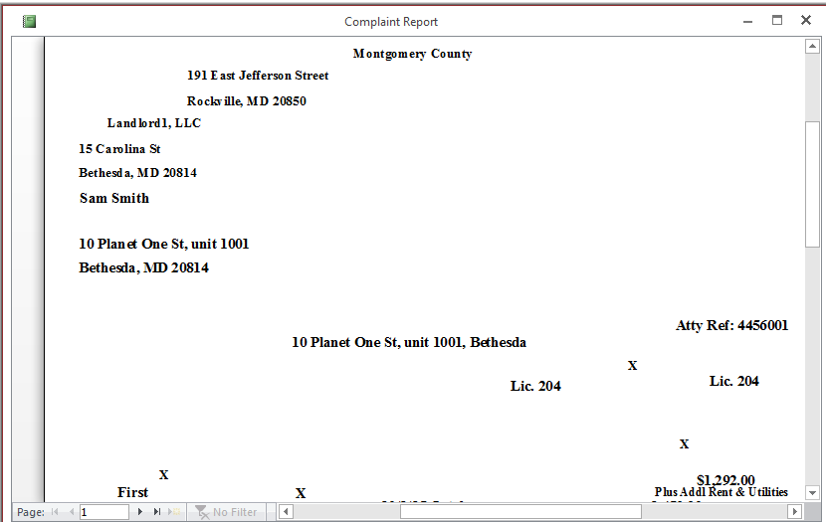

Figure

Right-click to **Print**. You can select all, or specific pages.

You can leave the Report Generator open while you return to LTWeb.

# Make Excel Helper for EFiling Complaints

The Excel Helper is an excel spreadsheet of information about each complaint to be EFiled from the current Filing.

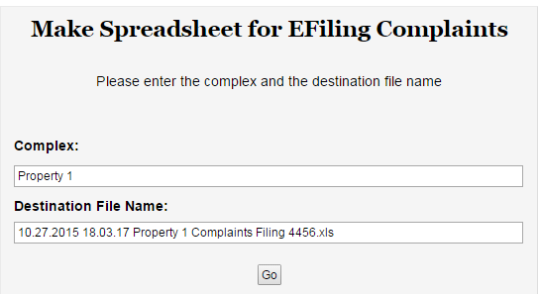

Figure

When you click **Go**, LTWeb downloads the Excel spreadsheet with the given name, based on the Filing, and the time the file was generated. Copy that file to the Helpers directory for using in EFiling with Win Automation (documented separately).

# Make Warrants for the Report Engine

This is very similar to printing Complaint. In the Tasks Option, click **Make Warrants for the Report Engine**.

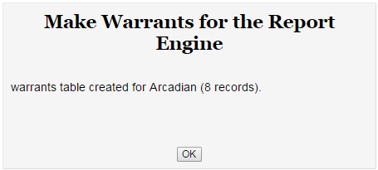

Figure

Please see the Making Complaints description, for the rest of the steps to print Warrants on pre-printed forms.

# Make Excel Helper for EFiling Warrants

The Excel Helper is an excel spreadsheet of information about each warrant to be EFiled from the current Filing.

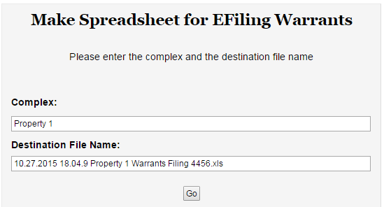

Figure

When you click **Go**, LTWeb downloads the Excel spreadsheet with the given name, based on the Filing, and the time the file was generated. Copy that file to the Helpers directory for using in EFiling with Win Automation (documented separately).

# Options for IDs

Clicking “Options for IDs” Opens a new Menu.

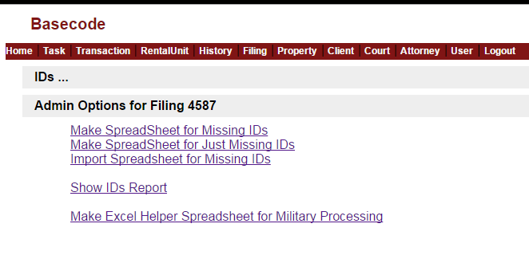

The **Make Spreadsheet for Missing IDs** and **Make Spreadsheet for Just Missing IDs** options are the same as for a normal user. It is documented in this manual in section **8.4 and 8.5.**

# Import Spreadsheet for IDs

Once a user has emailed back an Excel Spreadsheet with IDs and Birthdays, you save it from the email, and use “**Import Spreadsheet for Missing IDs**”. This work on spreadsheets that are for ALL IDs, and also those for MISSING IDs. Click **Choose File** to find the file on your disk, where you have saved it from the email.

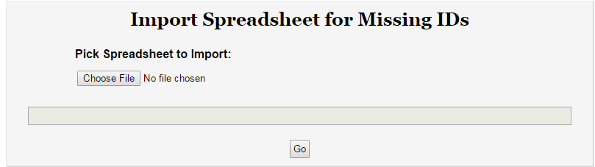

Note that the file name helps keep straight the Client who submitted the spreadsheet, and the Filing. Double-click on the file to select it.

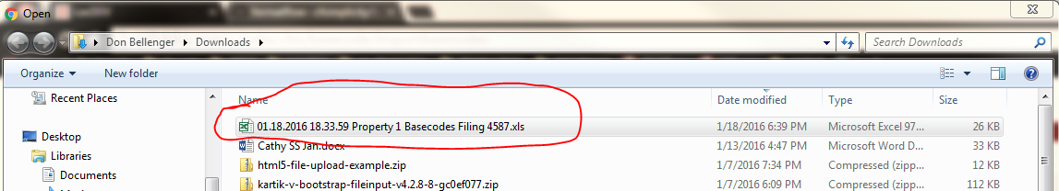

LTWeb will confirm the file selection. Click Go to upload the file into LTWeb.

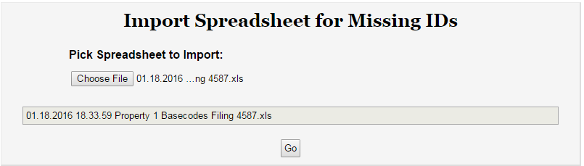

LTWeb will list any errors in the spreadsheet. In this case, there are no errors. If there errors, you can print the error report, and email it to your client.

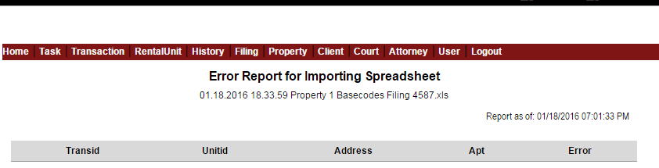

You should also Click Show IDs Report. DO NOT SEND THIS REPORT TO THE CLIENT, SINCE IT SHOWS IDs, AND IS A SECURITY RISK.

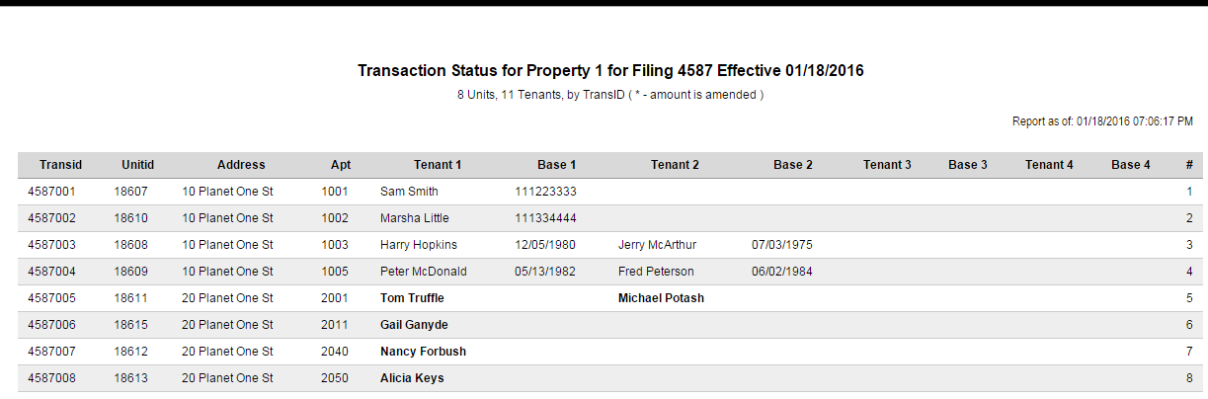

Notice that any tenant without an ID is shown in **Bold**. If there are any such tenants, contact your client, and ask then to **download a NEW spreadsheet**, and complete the missing entries. Note that their new spreadsheet will clearly indicate which Tenants have no IDs.

You can see the same spreadsheet they will see by selecting “Make Spreadsheet for Missing IDs”, and opening the downloaded file into Excel.



**The Client does not have to do anything for Tenants where there is already an (“X”) entry. We already have the ID’s or birthdays. The Client need only fill in ID or Birthday for those Tenants which have blanks.**

In the example above, the first 6 Tenants have been completed.

Once the client completes the spreadsheet by filling in the blanks, she should email it back to you. You then download the attachment from her email, and go through this same “Import Spreadsheet for Missing IDs” procedure, until you have all the IDs or Birthdays.

# Make Excel Helper Spreadsheet for Military Filing

One of the major advantages of having the IDs and Birthdays for each Tenant being sued is that you can get a spreadsheet to help in obtaining Military Affidavits by clicking “**Make Excel Helper Spreadsheet for Military Filing**”.

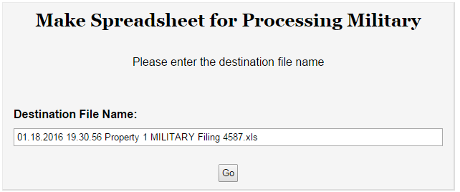

Accept the Destination File Name, and click Go. Load the download file into Excel.

For our example, the file looks like this. **Note that it has all the tenants begin sued, even though the Client only had to send in IDs for Tenants she had not sued before.**

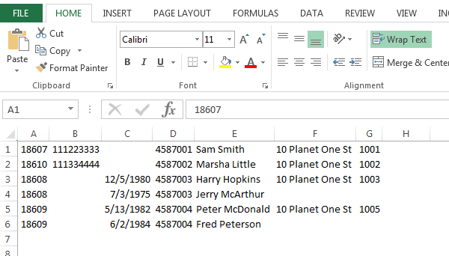

DO NOT SEND THIS FILE OUT OF THE OFFICE, SINCE IT CONTAINS IDs AND BIRTHDAYS. It is useful when pulling military affidavits, either manually, or in a procedure similar to EFiling.

# Appendix – Setting up a New Client and User in LTWeb

Before visiting a new Client user, it makes things run more smoothly if the Administrator does these steps, as described in the Adminitrator’s section of this manual. Click on the link to go there.

* Set up the Client Client (Adminitrative Options)
* Set up the Property Property (Administrative Options)
* Pick the Property as the Current Property
* Set up each client User for the new Client [User (Administrator Options)](#_User_(Administrator_Options))

# Appendix - Setting up a New User with Chrome and TeamViewer

We have designed LTWeb to run on the Chrome web browser. Be sure it is on the client’s machine by asking the user to bring up the “Chrome Browser” on her machine. If she can’t do it, you have to look for Chrome on her machine.

* It might be on the desktop, or on the toolbar. If so, double-click the icon.
* If not on the desktop or toolbar, click the Start button on the lower left of the machine. It may be on the menu that pops up. If so, click on the menu item

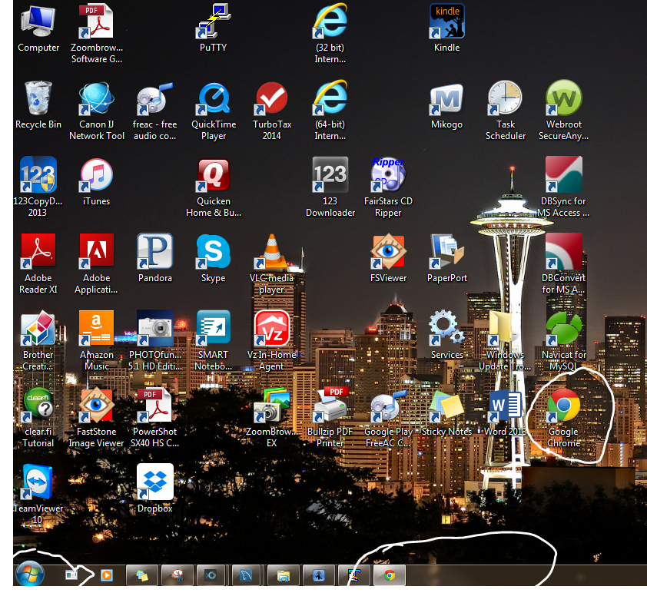

* If you haven’t found Chrome, click the start button on the lower left of your screen, and enter “Chrome” into the “Search programs and files“ Text Box shown below. If you find the icon, double-click it.

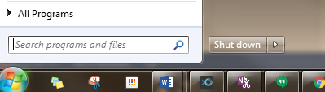

* After the above steps, if you still can’t find Chrome, install it from the web, using whatever browser she has (probably Internet Explorer) to download Chrome

1. Go to Google to Google
2. Search for “Download Chrome”.
3. Click on “Go to download”.
4. Click the download button, etc. The screenshots below show using Internet Explorer to get Chrome.

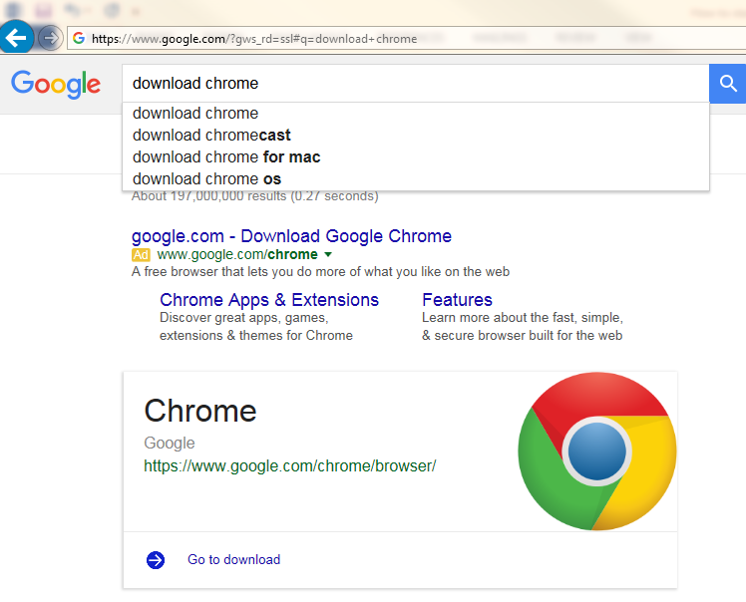

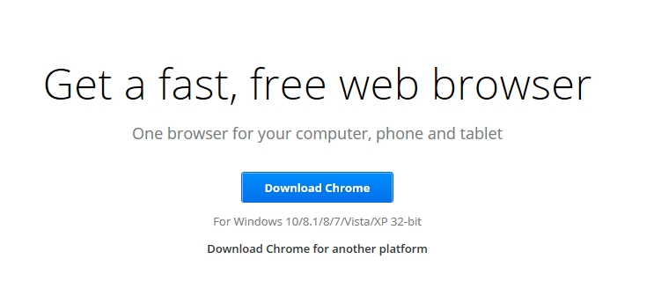

**After you get Chrome running, you want to install a bookmark to our site**.

* Start Chrome.
* Type **test.uisdesign.com** into the url box of the Chrome browser, as shown below. 
* When you hit return, the login box for LTWeb comes up.
* Hit **ctrl-d** right then to create the bookmark. Say that you want it to be on the Bookmarks Toolbar.
* The last step is to be sure the Bookmarks Toolbar is always visible. Do this by selecting the **Chrome Options** button (circled above). Then click on **Settings**, and then check **Always show the bookmarks bar**.
* Then close the Settings tab (circled).

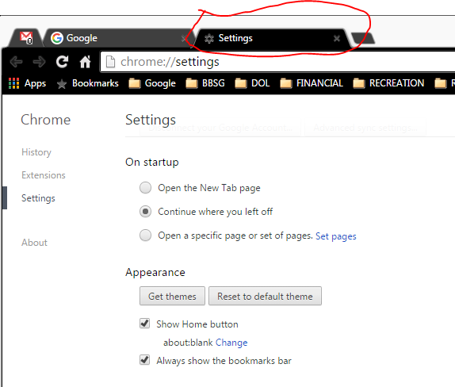

**To install Teamviewer, browse to teamviewer.com.**

* Click on **Download Free for private use.** This will download a file.
* 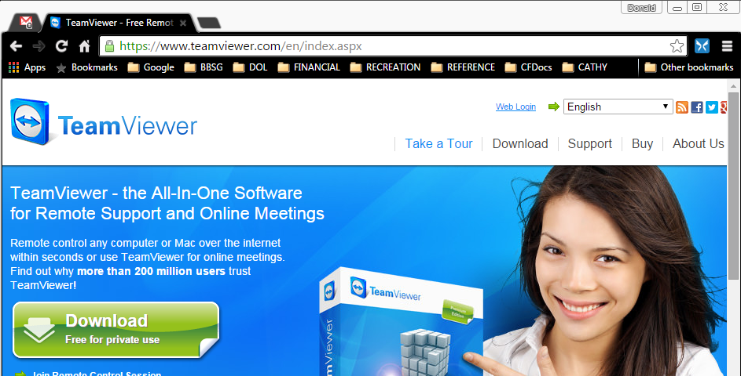
* **Open the file** to start the installation, and follow the prompts. This can take up to ten minutes to finish.